[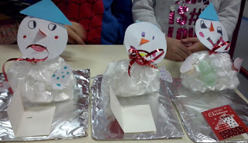](https://4.bp.blogspot.com/-YGkPg1gQWWE/XAF47gkz6DI/AAAAAAAAGUc/VOHSorFAgrcIiEFEJeqkZdPBDglccRKIwCLcBGAs/s1600/photo1.jpg)

[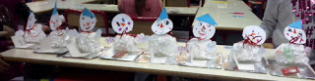](https://4.bp.blogspot.com/-hZ0aKZG3mrc/XAF48BZynaI/AAAAAAAAGUk/0SNjVvheI6E-_zNM1I6gL3VJ1W9wmNQSQCLcBGAs/s1600/photo4.jpg)

[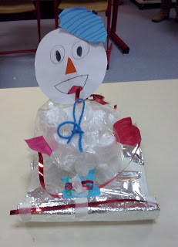](https://1.bp.blogspot.com/-j4iBoMEIDkk/XAF4-NgCj0I/AAAAAAAAGUw/HiCvFuiJNJoz1RUcSYRSSENygrguAdNfwCLcBGAs/s1600/photo7.jpg)